CLI Tester Project

# Introduction

The CLI Tester is a new service Vanrise plans to introduce to the telecom market as part of the company products portfolio. The targeted customers for this service is the Voice Carriers and international segments of the Mobile/PSTN operators.

As a part of revenue and quality assurance procedures, the carriers / operators require a tool to guarantee the CLI delivery to the end party. The CLI tester is the automated tool that answer this inquiry by simply generate a call from the customer network and compare the originated and terminated CLI information.

Technical Solution

The plan is to build a cloud base solution to be introduced to interested customers on monthly service contract. The registered customer will have a web access to the cloud service that allow generating a set of monthly calls to any of the Mobile or PSTN networks covered by Vanrise directly via local presence or indirect via international partners, and respectively determine whether the received CLI is true or fake. The customer has the freedom to choose the targeted network, number of retires and route call via the supplier under test, and immediately gets the test results as a quality report generated by the service.

The networks covered by the service requires a worldwide presence and vary from Mobile to PSTN or CDMA in some cases. To achieve the global coverage, a continuous efforts is required to add non covered or newly deployed networks and to maintain the customer’s satisfaction.

The network type will define the approach to connect to the network service as described below:

Mobile Network

In this case, the roaming SIM box / SIM server strategy will be the best solution, where Sims from all the mobile networks that have roaming service within the country hosts the SIM box can be used.

The SIM server will facilitate a centralized setup which is allow easier management and less maintenance cost.

In case of the networks that doesn’t have roaming coverage, a physical SIM box equipment can be installed where received calls to SIM box forwarded as VOIP calls to our VOIP server.

**Hardware requirements**

The hardware required to build the solution can be classified according to the equipment location as follows:

* Centralized Site

The main site where most of the solution core equipment installed and most of the support activities to be done.

* + Windows Server
  + Internet DSL Router
  + Backup Power supply
* Remote Site

Our Partner has Sim boxes distributed worldwide which can be used by our CLI Tester using API functions.

**Software requirements**

The software part of the project composed of two components working independently, the client Web App and the server App (Cloud-base Application), and the following describes each of them:

* Client side component

Customer will use a Web interface and register to our server and send requests to the CLI Tester application, and allow them to do the following:

1. Define supplier’s routing prefix
2. Define Targeted Networks (Code, Zone)
3. Initiate manual test call to a specific network over a specific supplier
4. Configure a runnable task to generate test calls to a set of networks over a specific supplier(s)
5. Monitor the testing results, and repeating them if necessary
6. Issue testing calls, results reports

* Server side component

1. Web Server
2. Agent
3. Call Generator
4. SQL Database

Call flow Plan

To integrate the solution with the customer network, a client application/hardware (VOIP Call Generator) should be interconnect to the customer switch in order to generate testing calls towards the designated network.

The customer purchases a license for a predefined number of attempts monthly package towards any of the networks covered by Vanrise CLI verification service.

The solution user has ability to do the following:

1. Route the call to selected supplier to verify the CLI delivery.
2. Modify the originated CLI and trace the call flow from to ensure the call delivery to end point
3. Distribute the package attempts among the desired networks and suppliers

The following equipment should be installed on the customer site to access the CLI detection service:

1. PC with windows OS, using Firefox browser
2. DSL Internet router to connect to our call generator.

Call flow network diagram

1. Send web Request including the CLI and the zone name.
2. Monty will send back the CDPN and the Session ID
3. Send request to dialer to call the CDPN
4. Dialer will dial the CDPN
5. Sim box will send the CDR for this call to Monty engine
6. Monty agent will send back the CLI and CDPN with the Session ID to our engine

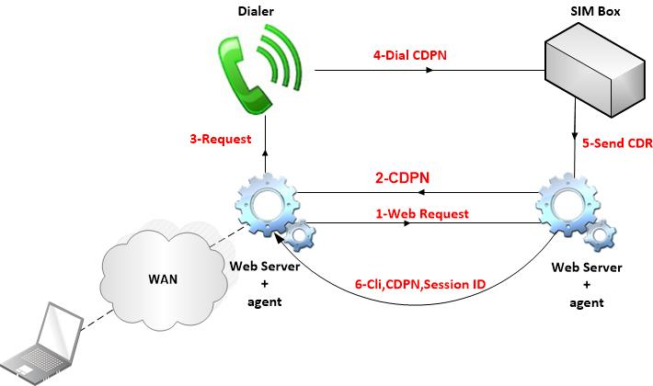

Developers Work:

* Client Side:
  1. Login to our CLI Tester
  2. Admin User with admin roles
     1. Create Roles
     2. Create Users with different privileges

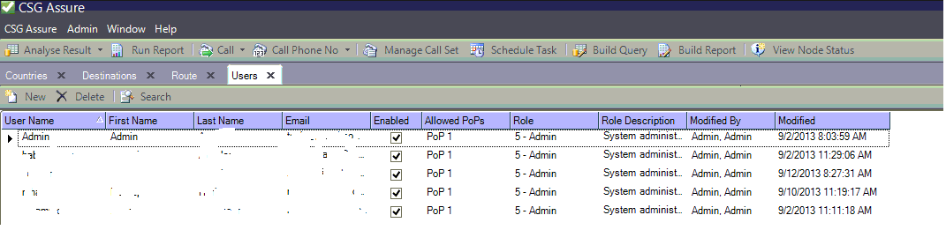

* 1. Administration Parameters
     1. Edit CLI

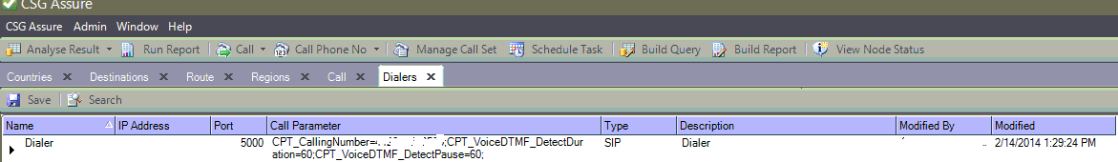

* + 1. Upload Codes and Zones

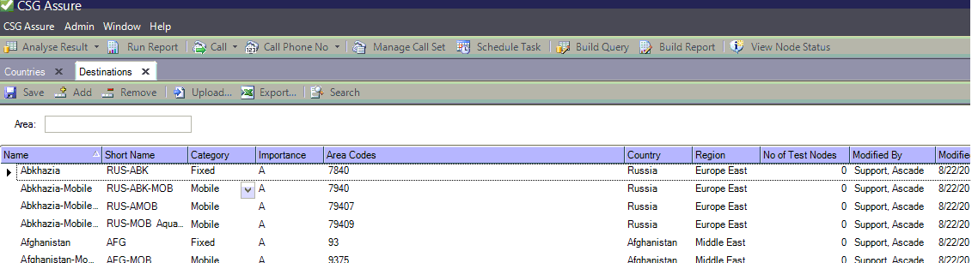

* + 1. Upload Routes for each carrier with different prefix

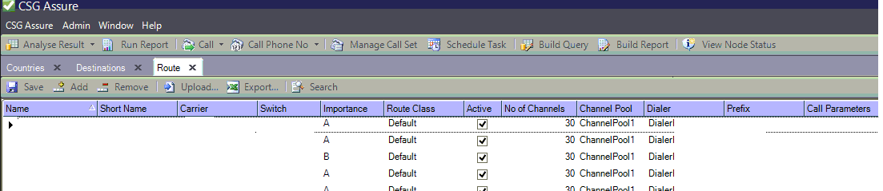

* 1. Call Page:
     1. Test Type
        1. CLI
        2. FAS
        3. MOS
     2. Select Route
     3. Countries
     4. Destination

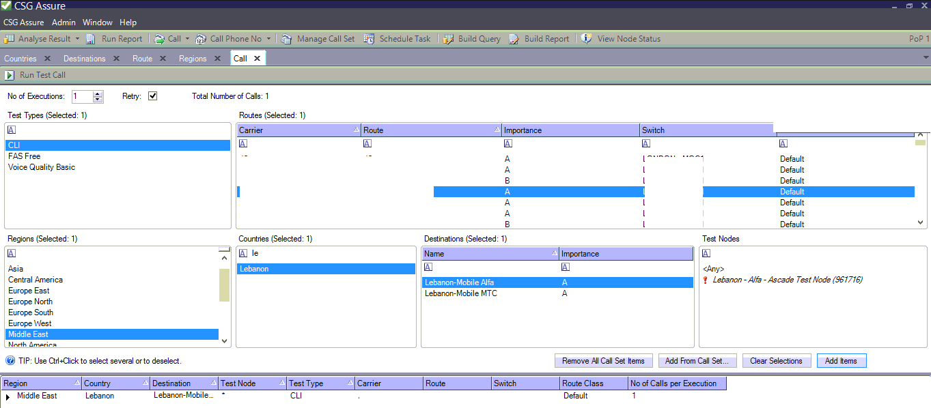

Result of the call



* 1. Schedule Task

Type a name for the task, and then choose one of the following options:

* + Time
    - Daily
    - Weekly
    - Monthly
    - One Time only
  + Test Type
  + Destination
  + Route

Define this task as a job and put it in a queue

* Server Side:

1. Define ID for each Customer
2. Create table for Codes and Zones with the customer ID
3. Create table for suppliers(Carriers, Prefix) with the customer ID
4. Create table for countries contains our zones for all customers
5. Interconnect with the customer switch using Sip Protocol to be able to send calls from our call generator to the customer with different prefixes for every supplier.

Example: 000160 Supplier1

000161 Supplier2

Dial Plan should be: 000160+CDPN@CustomerIP

1. Web server and agent application:
   * + Our customers will send a request using our web application which contains the following:
       - * CLI
         * Country
         * Destination
         * Route

* + - After receiving the request from the customer we should send a web request towards Monty with the CLI and the operator code(each operator has a unique code)
    - Monty response will contains the request ID and the MSISDN(CDPN)
    - Send a request to the call generator to call this CDPN using the client parameters (CLI, Prefix...).
    - Dialer will send the call through the customer switch with the supplier prefix.
    - If the call is successfully completed we should receive or send a web request with the same request ID and Monty will reply with the status of this call.
    - Send the result to the client web application

Sample of the Services

1) Get the list of all available operators to test for CLI :

<http://93.89.95.9/testnum/rest/request.php?test_method=GETOPCALL>

2) Request a test for CLI support:

Example the below request a CLI test to SriLanka Mobitel ( with MCC-MNC=4130 which is the operator code listed from the first link )

<http://93.89.95.9/testnum/rest/request.php?test_method=CALLCLI&test_cli=32468109432&operator_code=41301&test_tag=IDT&customer_id=1>

This will return:

{"response":"TRUE","message":{"RequestID":1202,"MSISDN":"94710517393"}}

the MSISDN contain the number to dial and the submitted test_cli need to be sent to track if the call received from this CLI or not.

the Request ID : 1202 will be used in the next service to know if CLI is supported or not

3) To get the request status given request ID:

<http://93.89.95.9/testnum/rest/request.php?test_method=GETREQUEST&request_id=1202>